1. Team Formation & Introductions
Team Name - CodeBreakers
Team Members Name:
- Khushi Kumari
- Ann Treesa Raphi
- Alphin Vargheese

2. Project Idea Generation & Discussion
Brainstormed Ideas:
- Expense tracking
- Budget planning
- Savings calculation
- Visualization with interactive charts
- Data persistence with local storage and import/export features
Final Chosen Idea:
Personal Finance Tracker – A web-based tool that helps users manage their income, track expenses, set budgets, and visualize financial health through charts and data.

3. Finalize Project Concept
The application enables users to:
- Add income/expenses
- Set monthly category-based budgets
- View summary stats like income, expenses, net savings, and savings rate
- Visualize expenses by category and time (Pie, Bar, and Line Charts)
- Import transactions from CSV
- Export data in JSON format

4. Develop Initial Wireframes/Mockups

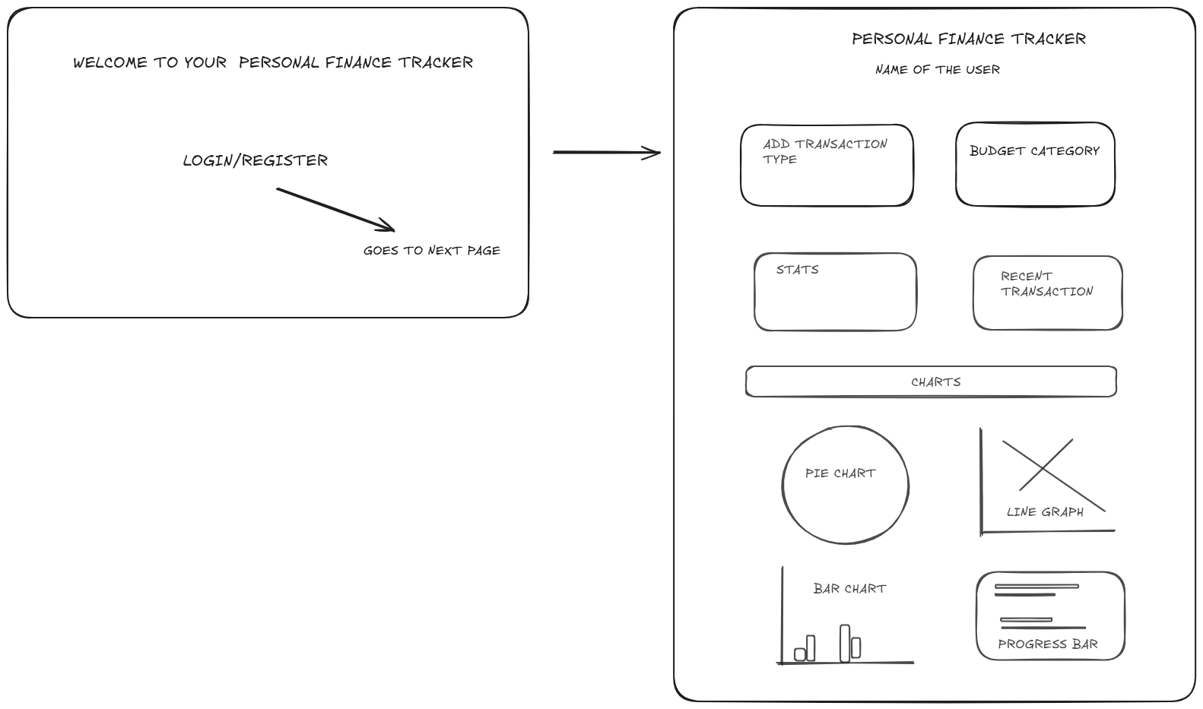

5. Software Requirements Specification (SRS)

Project Aim/Goal
To develop a responsive, interactive, and easy-to-use personal finance tracker that helps users understand, manage, and plan their finances efficiently.

Initial Technology Stack
Layer | Technology
Frontend | HTML5, CSS3, JavaScript
Data Storage | localStorage API
Charts | Canvas API
File Ops | FileReader (for CSV), Blob (for JSON)
Tooling | VSCode, GitLab

High Level Architecture Daigram
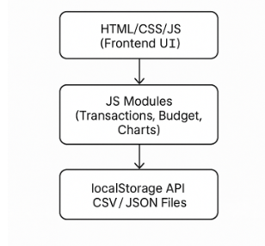

Key Use Case Diagram

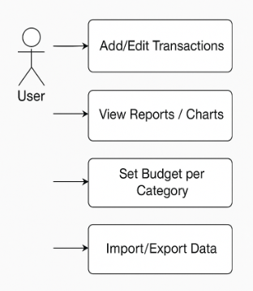

Roles
- Normal User: Can add transactions, set budgets, view charts, import/export data.

Core Workflow(s) & User Flows

Add Transaction Flow
- First we will make a welcome page , where we will write Welcome to Personal Finance Tracker then after clicking next button we will go to next page.
- User selects type (income/expense)
- Enters amount, category, description, and date
- Clicks "Add" button
- Data is saved to localStorage
- UI updates with new transaction and stats

Budget Setting Flow
- User selects category
- Inputs monthly budget limit
- Clicks "Set Budget"
- Budget is saved and shown with a progress bar

Chart View Flow
- User adds multiple transactions
- Pie/Bar/Line charts automatically update based on stored data

CSV Import Flow
- User uploads CSV file
- FileReader parses data and adds transactions
- UI updates accordingly

JSON Export Flow
- User clicks "Export Data"
- JSON file of transactions is generated and downloaded

